Power BI Desktop
Fast Food Restaurants by City
Total Restaurants by city
Berlin
Hamburg
München
Köln
Leipzig
Frankfurt am Main
Dresden
Bremen
Nürnberg
Stuttgart
Hannover
Düsseldorf
Dortmund
Essen
Mannheim
K
3
1
K
K
1
K
1
1
K
K
1
0
K
0
K
K
0
0
K
K
0
0
K
0
K
K
0
0
K
Berlin
Hamburg
München
Köln
Leipzig
Frankfurt am Main
Dresden
Bremen
Nürnberg
Stuttgart
Hannover
Düsseldorf
Dortmund
Essen
Mannheim
Power BI Desktop
Restaurants per 100,000 People by State
Restaurants per 100k (State) by Bundesland

Something's wrong with one or more fields.
s
See detail
Fix this
McDonald's Locations by City
McDonalds per 100k by city
0.02
0.04
0.06
0.08
0.10
0.12
0.14
0.16
Number of McDonald's Restaurants
Berlin
Hamburg
München
Köln
Bremen
Düsseldorf
Frankfurt am Main
Hannover
Nürnberg
Stuttgart
0.156
0.037
0.037
0.041
0.082
0.085
0.041
0.041
0.037
0.126
Power BI Desktop
Total Restaurants by State
Restaurants per 100k by bundesland
0
2
4
6
8
10
Number of Restaurants
Nordrhein-W
estfal…
Bayern
Baden-Württemberg
Niedersachsen
Hessen
Berlin
Sachsen
Rheinland-Pfalz
Schleswig-Holstein
Brandenburg
Mecklenburg-V
orpommern
Hamburg
Sachsen-Anhalt
Thüringen
Saarland
Bremen
Blank
)
(
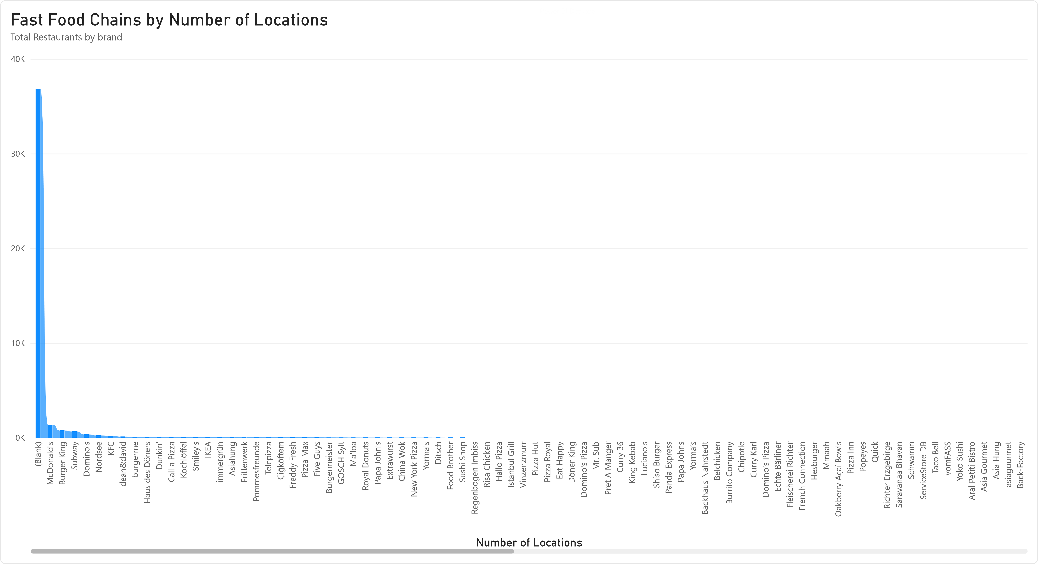
Power BI Desktop
Three Smallest Towns
city
Total Restaurants


Restaurants per 100k
Adelsdorf
1
0.00
Teterow
3
0.00
Templin
9
0.01
Total
13
0.02
Three Largest Cities
city
Total Restaurants


Restaurants per 100k
Berlin
2807
3.33
Hamburg
1157
1.37
München
813
0.97
Total
4777
5.67
